Name: Jatvish Yechuri
Reg no: 220905246
Roll no: 36
CSE – C
Title: CD Lab – 2
Date: 15/1/2025

sample program: Program to remove single and multiline comments from a given ‘C’ file.

Code:
#include <stdio.h>
int main()
{
FILE *fa, *fb;
int ca, cb;
fa = fopen("sample_in.c", "r");
if (fa == NULL){
printf("Cannot open file \n");
exit(0);
}

fb = fopen("sample_out.c", "w");
ca = getc(fa);
while (ca != EOF)
{
if(ca==' ')
{
putc(ca,fb);
while(ca==' ')
ca = getc(fa);
}
if (ca=='/')
{
cb = getc(fa);
if (cb == '/')
{
while(ca != '\n')
ca = getc(fa);
}
else if (cb == '*')
{
do
{
while(ca != '*')
ca = getc(fa);
ca = getc(fa);
} while (ca != '/');
}
else
{
putc(ca,fb);
putc(cb,fb);
}
}
else putc(ca,fb);
ca = getc(fa);
}
fclose(fa);
fclose(fb);
return 0;
}

Screenshots:

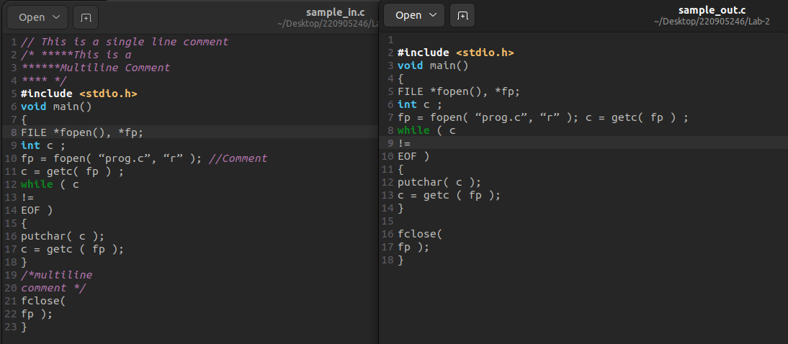

Q1. WAP that takes a file as input and replaces blank spaces and tabs by single space and writes the output to a file.

Code:

#include <stdio.h>
#include <stdlib.h>

int main() {
FILE *fa, *fb;
int ca, prev_ca;

fa = fopen("1_in.c", "r");
if (fa == NULL) {
printf("Cannot open input file\n");
exit(0);
}

fb = fopen("1_out.c", "w");
if (fb == NULL) {
printf("Cannot open output file\n");
fclose(fa);
exit(0);
}

ca = getc(fa);
prev_ca = '\0';

while (ca != EOF) {

if (ca == ' ' || ca == '\t') {

if (prev_ca != ' ' && prev_ca != '\t' && prev_ca != '\0') {
putc(' ', fb);
}
} else {

putc(ca, fb);
}

prev_ca = ca;
ca = getc(fa);
}

fclose(fa);
fclose(fb);

return 0;
}

Screenshots:

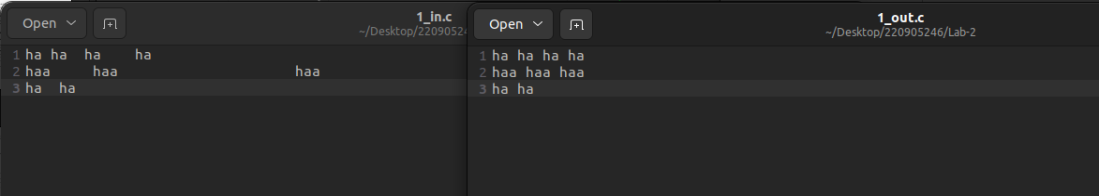

Q2) To discard preprocessor directives from the given input ‘C’ file.

Code:
#include <stdio.h>
#include <stdlib.h>

int main()
{
FILE *fa, *fb;
int ca, cb;

fa = fopen("2_in.c", "r");
if (fa == NULL) {
printf("Cannot open input file\n");
exit(0);
}

fb = fopen("2_out.c", "w");
if (fb == NULL) {
printf("Cannot open output file\n");
exit(0);
}

ca = getc(fa);
while (ca != EOF) {

if (ca == '#') {
while (ca != '\n' && ca != EOF) {
ca = getc(fa);
}
}

else {
putc(ca, fb);
}

ca = getc(fa);
}

fclose(fa);
fclose(fb);
return 0;
}

Screenshots:

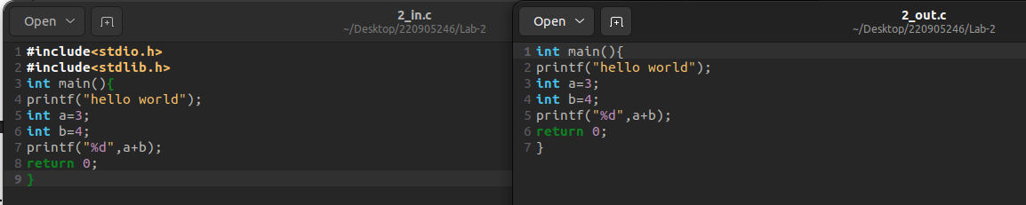

Q3) That takes C program as input, recognizes all the keywords and prints them in upper case.

Code:

#include <stdio.h>
#include <stdlib.h>
#include <string.h>
#include <ctype.h>

int main() {
FILE *fa, *fb;
int ca, cb;
char word[100];

fa = fopen("3_in.c", "r");
if (fa == NULL) {
printf("Cannot open input file\n");
exit(0);
}

fb = fopen("3_out.c", "w");
if (fb == NULL) {
printf("Cannot open output file\n");
exit(0);
}

ca = getc(fa);
while (ca != EOF) {
int i = 0;

while ((ca != ' ') && (ca != '\n') && (ca != EOF) && !ispunct(ca)) {
word[i++] = ca;
ca = getc(fa);
}
word[i] = '\0';

if (strcmp(word, "if") == 0 || strcmp(word, "int") == 0 ||strcmp(word, "for") == 0 || strcmp(word, "else") == 0 ||strcmp(word, "while") == 0) {

for (int j = 0; word[j] != '\0'; j++) {
word[j] = toupper(word[j]);
}
fprintf(fb, "%s", word);
} else {

fprintf(fb, "%s", word);
}

if (ca != EOF && (ca == ' ' || ca == '\n' || ispunct(ca))) {
putc(ca, fb);
ca = getc(fa);
}
}

fclose(fa);
fclose(fb);
return 0;
}

Screenshots:

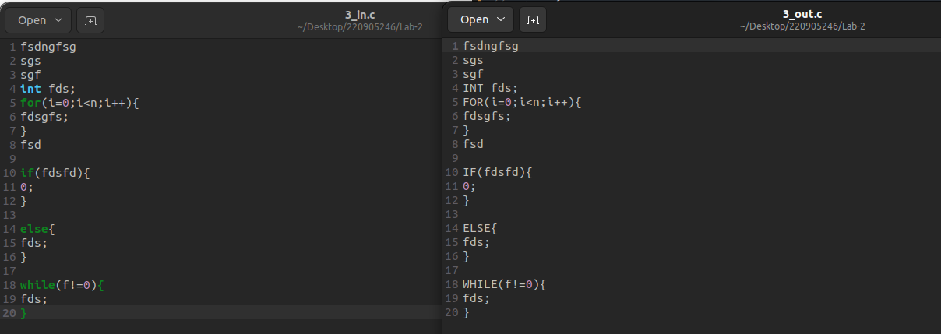
Did only for the keywords:
1. int
2. for
3. if
4. else
5. while

